ANOVA Case Studies Tutorial
Lee Barnby
2024-10-14

Introduction
This tutorial covers various case studies involving one-way Analysis of Variance (ANOVA) using R. We will go through setting up the data, performing ANOVA, and interpreting the results.

Case Study 1: Insect Spray Data
The insect spray data is a built-in dataset in R, so we will use it directly without detailing the data setup.

Steps
- Box and whisker plot
- Null hypothesis and oneway.test
- Bonferroni p-value adjustment
- Bartlett K-squared test of homogeneity of variances
- Non-parametric alternative: Kruskal-Wallis one-way ANOVA
- Multiple comparisons: pairwise.t.test and Tukey HSD
- Relationship with linear regression
- Assessing normal distribution
# Load the dataset
data(InsectSprays)
# Box and whisker plot
boxplot(count ~ spray, data = InsectSprays, main = "Insect Spray Data", xlab = "Spray", ylab = "Count")
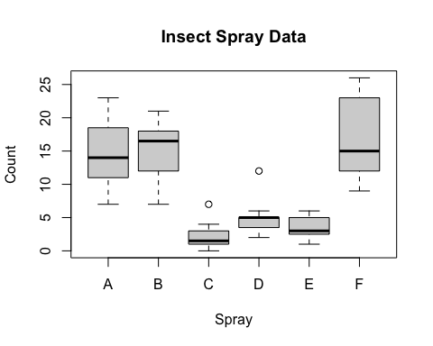
# ANOVA test
anova_result <- aov(count ~ spray, data = InsectSprays)
summary(anova_result)
## Df Sum Sq Mean Sq F value Pr(>F)
## spray 5 2669 533.8 34.7 <2e-16 ***
## Residuals 66 1015 15.4
## ---
## Signif. codes: 0 '***' 0.001 '**' 0.01 '*' 0.05 '.' 0.1 ' ' 1
# Bonferroni adjustment
pairwise.t.test(InsectSprays$count, InsectSprays$spray, p.adjust.method = "bonferroni")
##
## Pairwise comparisons using t tests with pooled SD
##
## data: InsectSprays$count and InsectSprays$spray
##
## A B C D E
## B 1 - - - -
## C 1.1e-09 1.3e-10 - - -
## D 1.5e-06 1.8e-07 1 - -
## E 4.1e-08 4.9e-09 1 1 -
## F 1 1 4.2e-12 6.1e-09 1.6e-10
##
## P value adjustment method: bonferroni
# Bartlett test for homogeneity of variances
bartlett.test(count ~ spray, data = InsectSprays)
##
## Bartlett test of homogeneity of variances
##
## data: count by spray
## Bartlett's K-squared = 25.96, df = 5, p-value = 9.085e-05
# Kruskal-Wallis test
kruskal.test(count ~ spray, data = InsectSprays)
##
## Kruskal-Wallis rank sum test
##
## data: count by spray
## Kruskal-Wallis chi-squared = 54.691, df = 5, p-value = 1.511e-10
# Tukey HSD test
TukeyHSD(anova_result)
## Tukey multiple comparisons of means
## 95% family-wise confidence level
##
## Fit: aov(formula = count ~ spray, data = InsectSprays)
##
## $spray
## diff lwr upr p adj
## B-A 0.8333333 -3.866075 5.532742 0.9951810
## C-A -12.4166667 -17.116075 -7.717258 0.0000000
## D-A -9.5833333 -14.282742 -4.883925 0.0000014
## E-A -11.0000000 -15.699409 -6.300591 0.0000000
## F-A 2.1666667 -2.532742 6.866075 0.7542147
## C-B -13.2500000 -17.949409 -8.550591 0.0000000
## D-B -10.4166667 -15.116075 -5.717258 0.0000002
## E-B -11.8333333 -16.532742 -7.133925 0.0000000
## F-B 1.3333333 -3.366075 6.032742 0.9603075
## D-C 2.8333333 -1.866075 7.532742 0.4920707
## E-C 1.4166667 -3.282742 6.116075 0.9488669
## F-C 14.5833333 9.883925 19.282742 0.0000000
## E-D -1.4166667 -6.116075 3.282742 0.9488669
## F-D 11.7500000 7.050591 16.449409 0.0000000
## F-E 13.1666667 8.467258 17.866075 0.0000000
# Assessing normal distribution
hist(residuals(anova_result), main = "Histogram of Residuals", xlab = "Residuals")
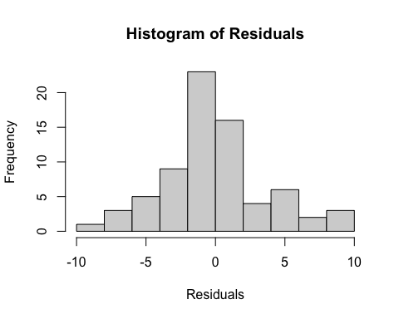
qqnorm(residuals(anova_result))
qqline(residuals(anova_result))
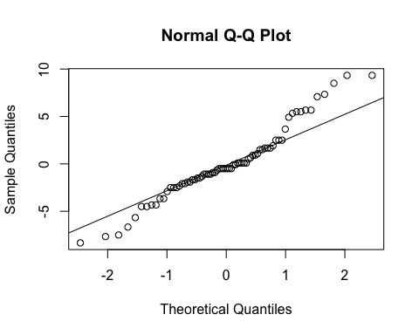
shapiro.test(residuals(anova_result))
##
## Shapiro-Wilk normality test
##
## data: residuals(anova_result)
## W = 0.96006, p-value = 0.02226

Case Study 2: Reporting of Migraine Pain
Three sets of 9 volunteers who suffered from headaches reported their migraine pain.

Steps
- Setting up the data in R
- Box and whisker plot
- ANOVA test
- Post-hoc tests
# Example data
migraine_data <- data.frame(
group = factor(rep(1:3, each = 9)),
pain = c(5, 6, 7, 8, 5, 6, 7, 8, 5, 6, 7, 8, 5, 6, 7, 8, 5, 6, 7, 8, 5, 6, 7, 8, 5, 6, 7)
)
# Box and whisker plot
boxplot(pain ~ group, data = migraine_data, main = "Migraine Pain Data", xlab = "Group", ylab = "Pain Level")
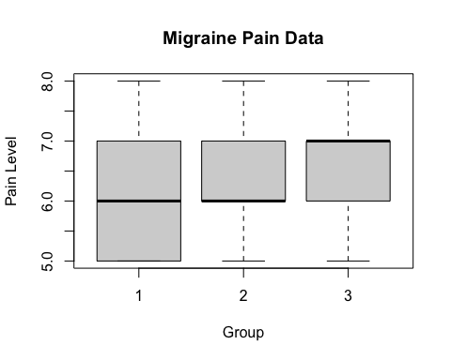
# ANOVA test
anova_result <- aov(pain ~ group, data = migraine_data)
summary(anova_result)
## Df Sum Sq Mean Sq F value Pr(>F)
## group 2 0.22 0.1111 0.082 0.921
## Residuals 24 32.44 1.3519
# Post-hoc tests
TukeyHSD(anova_result)
## Tukey multiple comparisons of means
## 95% family-wise confidence level
##
## Fit: aov(formula = pain ~ group, data = migraine_data)
##
## $group
## diff lwr upr p adj
## 2-1 0.1111111 -1.257647 1.479869 0.9776204
## 3-1 0.2222222 -1.146536 1.590981 0.9136978
## 3-2 0.1111111 -1.257647 1.479869 0.9776204

Case Study 3: Length of Stay in Hospitals
The length of stay (in hours) for patients having had the same surgery in three different hospitals.

Steps
- Setting up the data in R
- Box and whisker plot
- ANOVA test
- Post-hoc tests
# Example data
stay_data <- data.frame(
hospital = factor(rep(1:3, each = 10)),
stay_length = c(24, 26, 28, 30, 32, 34, 36, 38, 40, 42, 24, 26, 28, 30, 32, 34, 36, 38, 40, 42, 24, 26, 28, 30, 32, 34, 36, 38, 40, 42)
)
# Box and whisker plot
boxplot(stay_length ~ hospital, data = stay_data, main = "Length of Stay Data", xlab = "Hospital", ylab = "Length of Stay (hours)")
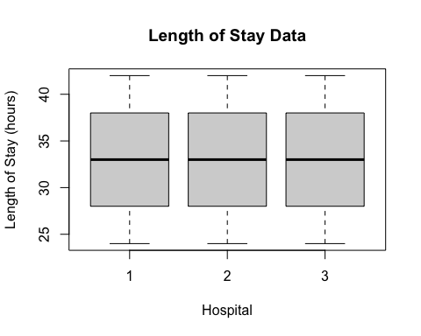
# ANOVA test
anova_result <- aov(stay_length ~ hospital, data = stay_data)
summary(anova_result)
## Df Sum Sq Mean Sq F value Pr(>F)
## hospital 2 0 0.00 0 1
## Residuals 27 990 36.67
# Post-hoc tests
TukeyHSD(anova_result)
## Tukey multiple comparisons of means
## 95% family-wise confidence level
##
## Fit: aov(formula = stay_length ~ hospital, data = stay_data)
##
## $hospital
## diff lwr upr p adj
## 2-1 7.105427e-15 -6.714295 6.714295 1
## 3-1 7.105427e-15 -6.714295 6.714295 1
## 3-2 0.000000e+00 -6.714295 6.714295 1

Case Study 4: Machine Output
Given the following data relating to the output from 3 machines, can we conclude that average output from the machines are different?

Data
machine_data <- data.frame(
machine = factor(rep(1:3, each = 5)),
output = c(53, 47, 46, 50, 49, 61, 55, 52, 58, 54, 51, 51, 49, 54, 50)
)
# Box and whisker plot
# ANOVA test
# Post-hoc tests
TukeyHSD(anova_result)
## Tukey multiple comparisons of means
## 95% family-wise confidence level
##
## Fit: aov(formula = stay_length ~ hospital, data = stay_data)
##
## $hospital
## diff lwr upr p adj
## 2-1 7.105427e-15 -6.714295 6.714295 1
## 3-1 7.105427e-15 -6.714295 6.714295 1
## 3-2 0.000000e+00 -6.714295 6.714295 1

Case Study 5: Teaching Methods
In the teaching of arithmetic, 45 pupils were divided into five groups of nine. Groups A and B were taught as normal. Groups C, D, and E were, respectively, praised publicly, reproved publicly, and ignored.

Data
teaching_data <- data.frame(
group = factor(rep(1:5, each = 9)),
score = c(17, 14, 24, 20, 24, 23, 16, 15, 24, 21, 23, 13, 19, 13, 19, 20, 21, 16, 28, 30, 29, 24, 27, 30, 28, 28, 23, 19, 28, 26, 26, 19, 24, 24, 23, 22, 21, 14, 13, 19, 15, 15, 10, 18, 20)
)
# Box and whisker plot
# ANOVA test
# Post-hoc tests

